**Business Segmentation**

**Demographic Segmentation:**

Age: Different age groups have varying nutritional needs and dietary preferences. Teenagers may focus on growth and development, while young adults might be more concerned with weight management or athletic performance. Middle-aged individuals may prioritize overall health and disease prevention, and seniors may have specific nutritional requirements to support aging well.

Gender: There may be gender-based differences in nutritional goals and dietary preferences. For instance, females may require additional nutrients during pregnancy or menopause. Understanding these differences helps tailor app features and content accordingly.

Location: Geographical factors can impact dietary habits and preferences. Different regions may have distinct culinary traditions, local produce availability, or cultural dietary restrictions. Consider adapting the app to accommodate these regional differences and provide relevant nutritional information.

**Psychographic Segmentation:**

Health Consciousness: This segment includes individuals who prioritize their health and actively seek information and tools to maintain a healthy lifestyle. They may engage in regular exercise, monitor their nutrient intake, and strive to make informed dietary choices. For this segment, the app can focus on providing in-depth nutritional information, personalized meal plans, and tracking features.

Lifestyle: Different lifestyles can affect nutritional needs and preferences. Busy professionals may require quick and convenient meal options, while athletes may need specialized nutrition plans for optimal performance. Individuals with dietary restrictions, such as vegans or those following gluten-free diets, would benefit from tailored recipes and ingredient substitutions.

Attitudes and Beliefs: Understanding attitudes and beliefs related to nutrition can help segment users based on their values and preferences. Some individuals may prioritize organic or locally sourced foods, while others may be motivated by sustainable eating practices. The app can cater to these preferences by offering organic food guides, sustainable sourcing information, or carbon footprint tracking features.

**Behavioral Segmentation:**

Usage Frequency: Segmenting users based on their app usage patterns can help identify highly engaged users and those who may need additional encouragement. Regular users can be targeted with loyalty programs, rewards, or personalized recommendations, while less active users may benefit from targeted reminders, notifications, or incentives to increase engagement.

Goals and Motivations: Users have different nutritional goals and motivations. Some may be focused on weight loss, muscle gain, or improving specific health conditions. By understanding these goals, the app can offer relevant features such as calorie tracking, personalized meal plans, workout integration, or condition-specific nutrition guides.

Purchase Patterns: Analyzing users' purchasing behavior within the app can help identify segments that are more likely to make in-app purchases or subscribe to premium features. These segments can be targeted with special offers, exclusive content, or personalized recommendations to drive conversions.

**Market Segmentation**

Market segmentation for a nutrient app involves dividing the overall market into distinct groups or segments based on specific characteristics and needs. These segments enable the app to target and tailor its marketing efforts to different customer groups effectively. Here's an explanation of the market segmentation for a nutrient app:

**Demographic Segmentation:**

Age: Segmenting the market based on age helps identify the unique nutritional requirements and preferences of different age groups. For instance, the app may target teenagers who are focused on healthy eating habits for growth, or seniors who require specific nutrients for age-related health concerns.

Gender: Gender-based segmentation recognizes the differing nutritional needs and goals between males and females. The app can provide specialized content and features addressing gender-specific concerns such as prenatal nutrition for females or muscle-building guidance for males.

Location: Geographical segmentation acknowledges the regional variations in dietary habits, cultural practices, and food availability. The app can adapt its content to cater to specific locations, offering regional recipes, local ingredient information, or nutritional guidance tailored to the local cuisine.

**Psychographic Segmentation:**

Health Consciousness: Segmenting based on health consciousness allows the app to target individuals who prioritize their well-being and seek nutrition-related information. This segment may include fitness enthusiasts, health-conscious individuals, or those managing specific health conditions.

Lifestyle: Segmentation based on lifestyle considers factors such as dietary preferences (e.g., vegan, vegetarian), fitness levels, activity levels, or specific dietary restrictions (e.g., gluten-free, lactose intolerant). The app can provide personalized meal plans, recipe recommendations, and nutrition tracking features to meet the unique needs of these segments.

Attitudes and Beliefs: Segmenting based on attitudes and beliefs related to nutrition helps the app understand customers' values and motivations. For example, some segments may prioritize organic foods, sustainable sourcing, or ethical eating practices. The app can provide information and features that align with these values, such as organic product recommendations or sustainable food guides.

**Behavioral Segmentation:**

Usage Patterns: Segmentation based on usage patterns involves categorizing users based on their frequency of app usage, engagement level, and interaction with app features. This segmentation helps the app identify highly engaged users, occasional users, and inactive users. Targeted marketing efforts, personalized notifications, and rewards can be used to increase engagement among different segments.

Goals and Motivations: Understanding the goals and motivations of users helps tailor the app's features and content to address their specific needs. Segments can include individuals aiming for weight loss, muscle gain, managing specific health conditions, or improving overall well-being. The app can offer personalized nutrition plans, goal tracking, and relevant content to support these goals.

Purchase Behavior: Segmenting based on purchasing behavior helps identify users who are more likely to make in-app purchases or subscribe to premium features. These segments can be targeted with promotions, discounts, or exclusive content to drive conversions and increase revenue.

**Global Diet and Nutrition Apps Market Size**

The Global Diet and Nutrition Apps Market is projected to grow at a CAGR value of 16.8% from 2022 to 2027.

The growing penetration of mobile apps in everyday life has been instrumental in the growing demand for diet and nutrition apps. Diet and nutrition tracking has been instrumental in the development of the diet and nutrition app market in recent years. The growing number of functionalities such as product scanners, calorie tracking, macro and micronutrient tracking, and activity tracking, among others, are expected to further the growth of the market.

The growing focus on new diets and dietary restrictions among the population has seen an increase in the number of diet-specific apps such as HappyCow which is a vegan diet-focused app. Other apps that have been highly functionalized to provide information and help customers track specific dietary requirements are becoming increasingly popular.

The subscription model has become increasingly popular among app developers. Subscription packages allow developers to provide customized content to customers, generate a steady revenue stream, and allow for greater protection against IP theft. Subscription-based apps are also becoming increasingly popular as they allow customers to conduct trials before completing the purchase and allow for greater flexibility.

Diet and nutrition tracking apps are becoming increasingly popular among mobile application users. As per Apple App Store and Google Play Store data, health and nutrition apps account for 3% of all apps offered. There has been an increase in demand for multi-functional apps with multiple functionalities in recent years as people look for one-stop solutions for all their fitness-related needs.

The diet and nutrition app market has been restrained by the increasing number of pirated apps being circulated. The growing number of apps in the market has increased competition among key players in the market. The growing demand for greater functionalities is expected to increase the cost of the development of diet and nutrition apps during the forecast period.

**COVID-19 Impact on Global Diet and Nutrition Apps Market**

The COVID-19 pandemic has increased the focus on nutrition and dietary practices among the population. The peculiar nature of the disease and the need to improve health conditions have led to an increase in demand for diet and nutrition apps. The growing percentage of people working from home has led to a greater number of people turning to dietary discipline to combat their growing sedentary lifestyles.

**Ukraine-Russia War Impact on the IT Industry**

Ukraine has been a major player in the IT industry in Europe owing to the availability of highly skilled programmers and developers at a lower cost. The conflict between Ukraine and Russia has in many ways led app developers to turn away from Ukraine for outsourcing their work. The withdrawal of major corporations from conducting business in Russia is expected to reduce the revenue generated by the diet and nutrition apps within Russia and Ukraine.

**Global Diet and Nutrition Apps Market: By Type**

The activity tracking segment is expected to be the largest diet and nutrition apps market segment based on the type. Diet and nutrition apps have increased functionality through activity tracking. The growing demand for tracking calories expended and calories consumed from various foods has led to the rapid growth in demand for the activity tracking segment.

The exercise & weight loss segment is expected to be the fastest-growing segment in the market. The growing number of apps that are being released for tracking exercises, the growing adoption of Fitbit and smartwatches for tracking physical activities, and the growing demand for customized exercise plans are expected to result in the rapid growth of the exercise & weight loss segment.

**Global Diet and Nutrition Apps Market: By Platform**

The android segment is expected to be the most prominent market segment based on the platform. The large number of android users and the cost-effectiveness of android devices have led to the domination of this segment over iOS. Android devices offer greater functionality and easier release of apps which has also led to the growing availability of android-based diet and nutrition apps.

The iOS segment is expected to be the fastest-growing segment in the diet and nutrition apps market, based on the platform. The growing demand for apple devices, increased expenditure on the development of iOS-only apps, and greater protection against IP theft in apple devices are expected to result in the rapid growth of the iOS segment during the forecast period.

**Global Diet and Nutrition Apps Market: By Device Type**

The smartphones segment is the largest market segment, based on the device type. The large and growing number of smartphone users, increased visibility, and greater functional support offered by smartphones has led to the devleopemnt of the smartphones segment.

The growing adoption of smartwatches and Fitbits, increasing investment in wearable medical devices, and the growing demand for integration of various wearable devices with diet and nutrition apps are expected to result in the rapid growth of the wearable devices segment.

**Global Diet and Nutrition Apps Market - Industry Trends and Forecast to 2028**

Global Diet and Nutrition Apps Market, By Type (Nutrition Tracking App, Activity Tracking App, Social Platform Apps, Wager Apps, and Others), Products (Smartphones, [Wearable Devices](https://www.databridgemarketresearch.com/reports/global-wearable-devices-market), [Tablets](https://www.databridgemarketresearch.com/reports/global-tablets-market)), Gender (Women, Men), Age (Adults, Teenagers, Aged), Platform (Android, IOS, Windows and Others), End-User (Fitness Centers, Healthcare Industries, Homecare Settings, and Others), Country (U.S., Canada, Mexico, U.K., Germany, France, Spain, Italy, Netherlands, Switzerland, Russia, Belgium, Turkey, Rest of Europe, China, Japan, South Korea, India, Australia, Singapore, Thailand, Malaysia, Indonesia, Philippines, Rest of Asia-Pacific, South Africa, Saudi Arabia, U.A.E., Egypt, Israel, Rest of the Middle East and Africa) Industry Trends and Forecast to 2028.

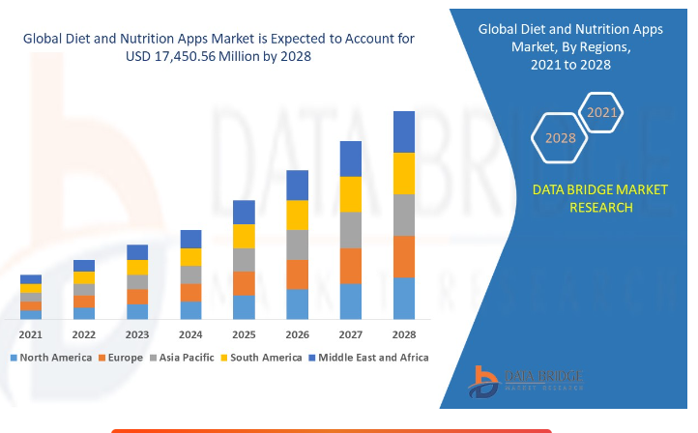

**Market Analysis and Insights: Global Diet and Nutrition Apps Market**

Diet and nutrition apps market is expected to grow in the forecast period of 2021 to 2028. Data Bridge Market Research analyses that the market is growing with a CAGR of 30.4% in the forecast period of 2021 to 2028 and is expected to reach USD 17,450.56 million by 2028.

The diet and nutrition apps are software applications used for tracking nutritional intakes and managing diets for healthy eating, weight loss, weight maintenance, weight gain, and fitness. Diet apps are also in demand for healthcare to track food sensitivities, allergies, and medical conditions, such as diabetes, high blood pressure, and heart disease. These app tools are offered in devices such as smartphones, tablets, and PCs. In recent years, the increased internet penetration and other digital services such as cloud computing have boosted the digital platform offering market. Mobile phone applications are used as tools by many users to get help in their daily tasks. Increasing awareness about health disorders due to unhealthy lifestyles has led to increased diet and nutrition apps.

The major factors driving the growth of the diet and nutrition apps market are the increasing penetration of digital devices and the internet, growing awareness regarding health and wellness, and scientific advancements in nutrition. Increasing use of smartphone apps owing to a surge in individuals with higher personal innovativeness is creating opportunities for the market's growth. Inconsistencies in nutrient coding are acting as the major restraint for the diet and nutrition apps market. Lack of awareness regarding specific functionalities and capabilities of nutrition apps is acting as a major challenge for the market's growth.

This diet and nutrition apps market report provides details of market share, new developments, and product pipeline analysis, the impact of domestic and localized market players, analyses opportunities in terms of emerging revenue pockets, changes in market regulations, product approvals, strategic decisions, product launches, geographic expansions, and technological innovations in the market. To understand the analysis and the market scenario, contact us for an Analyst Brief; our team will help you create a revenue impact solution to achieve your desired goal.

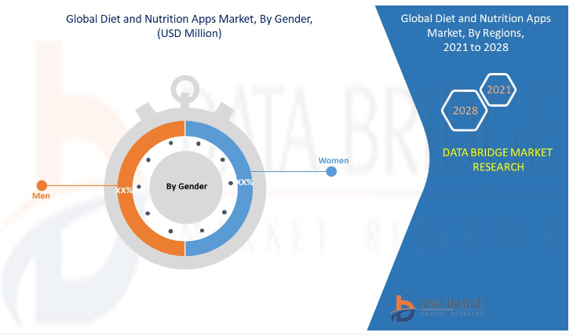

**Global Diet and Nutrition Apps Market Scope and Market Size**

The global diet and nutrition apps market is segmented based on type, products, gender, age, platform, and end-user. The growth among segments helps you analyze niche pockets of growth and strategies to approach the market and determine your core application areas and the difference in your target markets.

On the basis of type, the global diet and nutrition apps market is segmented into nutrition tracking app, activity tracking app, social platform apps, wager apps, and others. In 2021, the nutrition tracking app segment is expected to dominate the market as individuals have become more concerned about healthy eating and are using apps to track the nutrients present in food for a better healthy diet. Moreover, the nutrients tracking system also helps determine the most optimum food diet to choose as an alternative source of the product.

On the basis of products, the global diet and nutrition apps market is segmented into smartphones, tablets, and wearable devices. In 2021, the smartphone segment is expected to dominate the market as smartphones are more user-friendly and easy to install apps. The phone can be carried anywhere and can be used to track activities and nutrition intake throughout the day. Moreover, the adoption of smartphones has increased over the years, leading to a high market share.

On the basis of gender, the global diet and nutrition apps market is segmented into men and women. In 2021, the women segment is expected to dominate the market as the women use nutrition apps for better diet control and prepare healthy food through healthy food recipes. Moreover, it has been observed that women are more concerned about a healthy diet than men to maintain adequate body weight. In contrast, men are more inclined towards physical activities and workouts and are less focused on dieting apps.

On the basis of age, the global diet and nutrition apps market is segmented into teenagers, adults, and the aged. In 2021, the adult segment is expected to dominate the market as adults are more concerned about the nutrition and diet benefits, majorly using the diet and nutrition app. The adult population is adopting a healthy lifestyle to avoid chronic diseases such as obesity and diabetes.

On the basis of platform, the global diet and nutrition apps market is segmented into Android, iOS, Windows, and others. In 2021, the android segment is expected to dominate the market as android has witnessed high popularity in emerging economies, where price remains an important factor in consumer’s smartphone purchase decisions. Android is also more user-friendly as compared to other platforms and thus cater higher market share.

On the basis of end-user, the global diet and nutrition apps market is segmented into fitness centers, home care settings, healthcare industries, and others. In 2021, the fitness centers segment is expected to dominate the market as the growth in virtual fitness coaching has increased drastically over the pandemic, and most coaches are using online nutrition monitoring apps. Fitness centers have also seen significant growth due to the increasing concern of people towards their health.

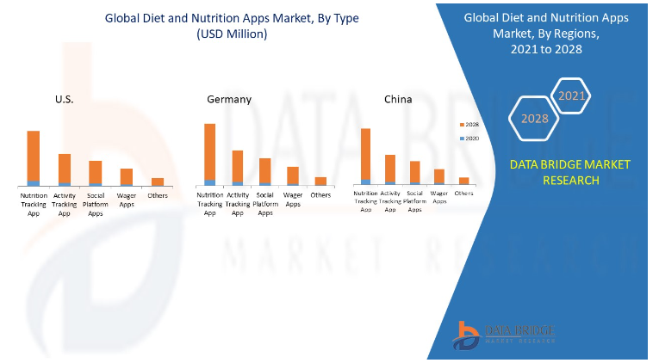

**Global Diet and Nutrition Apps Market Country Level Analysis**

Global Diet and nutrition apps market is analyzed, and market size information is provided by country, type, products, gender, age, platform, and end-user.

The countries covered in the global diet and nutrition apps market report are the U.S., Canada, Mexico in North America, U.K., Germany, France, Spain, Italy, Netherlands, Switzerland, Russia, Belgium, Turkey, Rest of Europe in Europe, China, Japan, South Korea, India, Australia, Singapore, Thailand, Malaysia, Indonesia, Philippines, Rest of Asia-Pacific, South Africa, Saudi Arabia, U.A.E., Egypt, Israel, Rest of the Middle East and Africa.

The North America is the dominating region. In 2021, North America is expected to dominate the market due to the high presence of top players in the region. The region has high adoption of smartphones that the users use as a platform for diet and nutrition apps. Moreover, the population is highly concerned about their eating habit and the nutrients present in their food.

The U.S. accounted for the maximum share in the diet and nutrition apps market due to a large number of dominating and local players in the region. Germany accounts for the second largest market as the region has witnessed high growth in population concerned about a healthy lifestyle. China has witnessed fast growth in the adoption of smartphones and penetration of the internet in the region used for apps.

The country section of the diet and nutrition apps market report also provides individual market impacting factors and changes in market regulation that impact the current and future trends of the market. Data points such as new sales, replacement sales, country demographics, regulatory acts, and import-export analysis are some of the major pointers used to forecast the market scenario for individual countries. Also, the presence and availability of global brands and their challenges faced due to large or scarce competition from local and domestic brands, the impact of sales channels are considered while providing forecast analysis of the country data.